Assignment 4.3 :
Consider a file named “names.txt” having entries of few names, these names are repeated as shown in the following image:
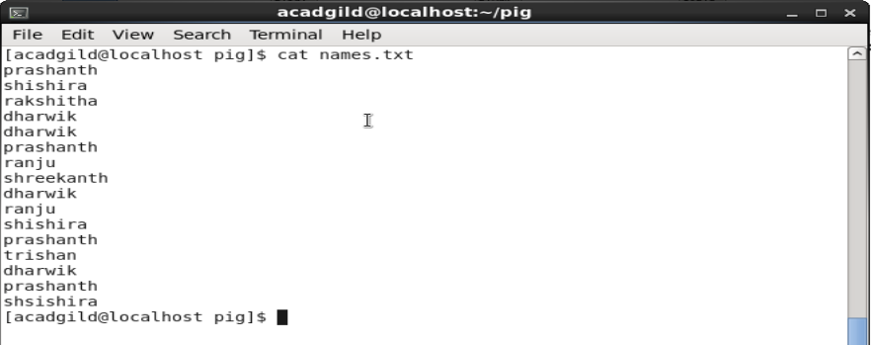
The problem statement is to find out how many times each word(names) have appeared in the file.
This can be done by writing a pig script which in turn converts it into a MapReduce program
The first step is to load the file into a relation. This can be done using the Load command.
Syntax: LOAD ‘/home/acadgild/pig/names.txt’ AS (line:chararaay);

The above command loads the names.txt into a relation named “Lines” .The relation will be formed as following:
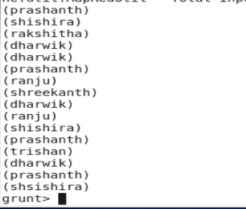
Flatten command is applied to each line in the relation. The bag is converted to a tuple by this command, The syntax is as follows:
Words = FOREACH LINES GENERATE FLATTEN (TOKENIZE(line)) as word;
In the next step the words are grouped together so the count logic can be applied on them.
Syntax: grouped = GROUP Words by word;
Group command output is as follows:
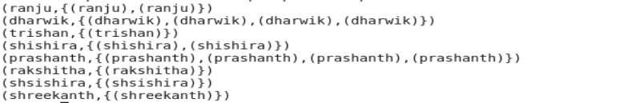
Now we can apply count logic on the grouped words.
Syntax: count = FOREACH grouped GENERATE group, COUNT(Words);

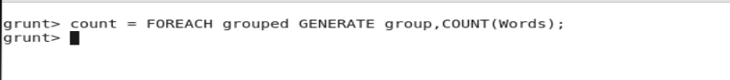
The final output shows the count of each words in the file.
